[STEAMatWork4Kids.org](http://STEAMatwork4kids.org) is a new website where kids can read about STEM role models of many races and ethnicities. We explore the rich diversity of topics and people in STEAM careers. Our target audience is students ages 8 - 12.

Each 300-word article is based upon an interview of a STEAM professional. Kid-friendly books and websites are suggested for students who want to learn more. The site also includes curriculum for teachers or librarians who want to use the website to teach language arts, science, math, or library skills. Or kids can explore on their own with a Career Quest activity.

Would you help me get this website into the hands of teachers or librarians who could use it with their students? Do you know of other organizations I should contact?

Thank you for any help you can give.

Sincerely,

Sharon Sivinski

Here is our banner in low def.

[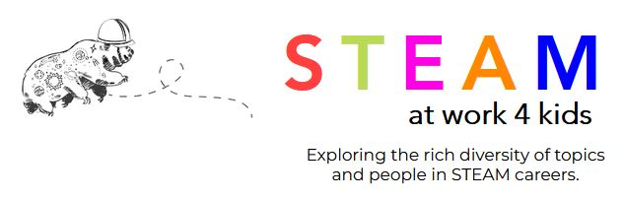](https://www.steamatwork4kids.org/)

Here is the logo in high definition if you’d rather.

[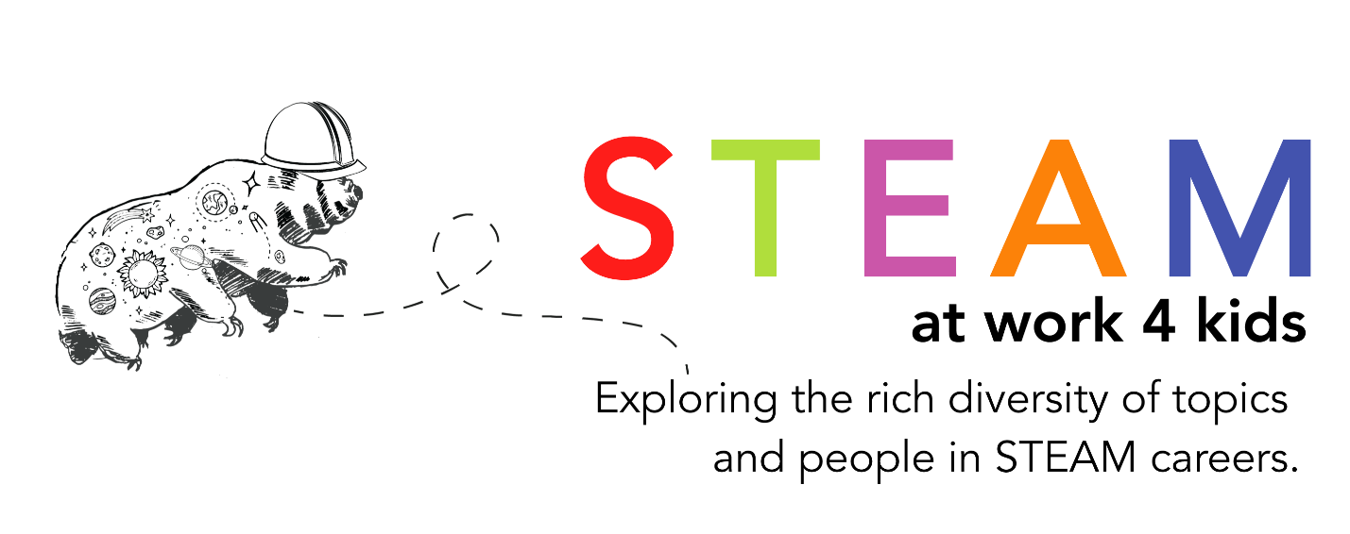](http://www.steamatwork4kids.org)